

BROADBAND INSTALLATION GUIDE

Guidelines prepared by

Mediacom Communications Corporation

INTRODUCTION – STATEMENT OF INTENT
The intended purpose of this installation guide is to provide approved methods and procedures for all phases of broadband installations and to serve as a general recommendation for daily work. In addition to this guide. Granite will provide technicians with the essential skills and information required to perform assigned task.
Mediacom will ensure that these guidelines are followed through ongoing reinforcement, quality control, customer surveys, and continual feedback between the technical staff and management.
A Note About Safety - Granite is concerned about the safety of its contractors and strives to provide a safe work environment. Contractors should become thoroughly familiar with Mediacom’s safety policies and procedures. In addition, training on pole climbing, ladder handling, and other safety issues will be made available to ensure that Granite contractors can perform their job in a safe manner. Granite will rent the contractor all Personal Protective Equipment (PPE) needed to safely perform work requirements.
It is every contractor’s responsibility to:
• Attend and participate in all required safety training.
• Demonstrate understanding and proper use of PPE.
• Participate in selecting PPE that properly fits.
• Use required PPE for designated tasks
• Adhere to manufacture’s safety recommendations and limitations for PPE
• Report and request a replacement for defective or damaged PPE.
• Do not use defective or damaged PPE.

Caution – Special precautions must be observed when working around electrical conductors, metal conduits, ground wires, meter bases, or any surfaces that could be exposed to AC power. Do not intentionally contact live conductors under any circumstances.

CONTRACTOS ROLE AS A MEDIACOM REPRESENTATIVE
Customer: Is one who wishes to use his or her entertainment dollars to expand Mediacom’s business.
Mediacom is a service company, and the technician is often the only representative whom customers meet. As a Mediacom representative, the technician should always strive to maintain a neat appearance, as well as a friendly attitude when dealing with customers.

Appearance and Presentation
Appearance is important in creating a businesslike image to Mediacom’s customers. There is probably no other position where a neat appearance is more important than that of a field representative. Technicians meet face to face with customers on a daily basis. Appearance not only defines the technician’s professional image, but also that of Mediacom And Granite.
Granite has adopted the following general guidelines to maintain a standard of grooming and dress that reflect an image of professionalism.
General Hygiene - Cleanliness, careful grooming, and neatness of apparel must be given full consideration.
Hair - Hair should be worn to the top of the collar. Longer hair must be pulled back in a ponytail or pulled under a hard hat. Beards, mustaches, and sideburns must be neat and trimmed. Extreme hairstyles are not acceptable.
Uniforms - Uniforms should be clean and neat with shirt tucked into trousers. An extra shirt should be kept in the truck in the event it becomes soiled. Boots should be kept clean and free from excessive wear. Clean dirt off shoes, remove overshoes, or wear disposable shoe covers before entering a customer’s building
Company Identification Badge – Contractors must always wear a Mediacom ID badge on the job. However, it may be removed when performing duties where it might present a safety hazard, such as climbing poles. In such cases, the badge should be removed, but always replaced before reentering customer’s residence.
Vehicles - Vehicle appearance also reflects Granite’s image and technician’s professionalism. Vehicles should be maintained, driven, and parked in a manner that will create a positive impression.
Anyone operating a company vehicle must abide by Mediacom’s vehicle policies, procedures, and all other listed inspection requirements. Additionally, the following general guidelines should be observed:
Vehicles must be maintained in a clean, orderly, and safe manner:
• Wash the vehicle at least once a week or on an as-needed basis. Keep cab interior clean and clear.
− Keep storage areas neat and orderly.
− All parts, equipment, and tools must be stored in their proper bins.
− Keep dashboard free and clear at all times. Place any trash in container.
− Secure meters or test equipment with passenger seat belts, or store in bins.
− Check fluid levels and tire pressures daily.
− Report any unsafe condition when known.
• Safety cones must always be placed at front and rear of vehicle when parked at side of road. When backing into parking space, one cone is to be placed in front of vehicle. If necessary, to pull directly into space, one cone is to be placed in rear of vehicle.
Customer Relations
Following are some specific guidelines to help technicians develop and maintain excellent customer relations.
• Technician’s should only enter customer’s residence after verifying that customer or his or her representative is at least 18 years of age.
• Always be courteous to customer and respectful of his or her property.
• Avoid parking in customer’s driveway if possible.
• Arguing with customer is counterproductive. Answer a frustrated customer’s questions calmly and politely.
• Avoid language that could be considered offensive by customer. Comments about customer’s appearance are always inappropriate.
• If installation involves drilling, inform customer and secure his or her approval before starting.
• Use care when working inside. Tools placed on furniture or TV set cabinet will cause damage.
• Clean up thoroughly when finished with installation. Be alert for wood shavings, clips, cable scraps, or tools.
• If customer’s property is accidentally damaged, note on Work Order. Explain to customer that Granite supervision will contact him or her shortly. Many systems require a damage report be completed before leaving premises. Check with supervision or management.

Crafting High Quality Installations
An important key to delivering superior broadband service is by crafting high quality installations. The drop system is the most critical part of the broadband network and must be designed, built and maintained with utmost care. The “twenty plus year installation” concept includes:
• Selecting appropriate drop cable type i.e. messenger cable to support aerial drop, self-sealing underground cable for buried drop, etc.
• Using correct drop cable size that ensures proper levels at customer equipment. Verification by measuring levels in several frequency bands.
• Selecting appropriate fasteners and correctly anchoring drop cable to building.
• Sealing cable from moisture penetration by means of an approved “F” connector correctly installed. o Additional weather protection is obtained by applying silicone grease or F-Seal to all exterior cable connections.
• Properly tightening connectors to prevent possible ingress, egress and/or signal degradation. Maintain drop integrity by monitoring signal leakage with proper test equipment.
• Using only approved methods of bonding/grounding drop system to protect equipment and people.
• Keeping the customer informed about broadband services/products, equipment and the installation process.
OVERVIEW OF TYPICAL BROADBAND NETWORK
Most broadband networks can be subdivided into four major parts:
- Head end, where signals/information is received, processed, and combined onto network.
- Fiber optic system, which distributes combined signals to major areas of network (hubs) or optical nodes.
- Distribution network, consisting of low loss coaxial cable, trunk-bridger amplifiers and line extender amplifiers that pass each building served
- Service/house drop that taps signal from feeder to serve individual customer or business.
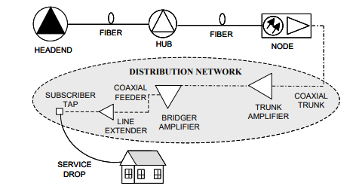

Digital Signals
Digital transmission is a mode in which all information to be transmitted is first converted to digital form and then transmitted as a serial stream of pulses. Any signal…voice, data or television can be converted to a digital form.
Signal Level Requirements
Maintaining and delivering required signal levels is one of the most important factors in delivering high quality service to customers. Listed below are normally measured video carrier levels.
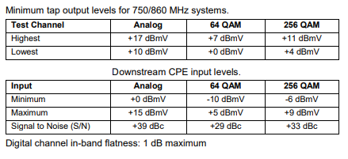
RF Levels
Radio Frequencies (RF) signals on the network are measured in dBmV units rather than volts or amperes. Using the dB scale makes math calculations of RF levels less complicated and a matter of simple addition and subtraction.
Example: Signal level of a measured channel (Channel 116) and/or frequency (745.25 MHz) at port of tap is +15 dBmV and total drop loss is 6.5 dB. The output signal levels are as shown below
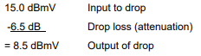
If a two-way splitter with a loss of 4.0 dB were inserted, output level would then be:
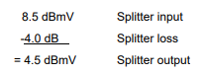
If a three-way balanced splitter with a loss of 5.0 dB were inserted instead of a two-way splitter, total loss would be:
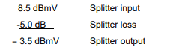
Calculating Drop Levels
Understanding how to calculate signal levels at various points in the drop system will help minimize the time spent on troubleshooting. In addition, it will help you to know what the proper signal levels should be at the tap and the customer’s set. Using this knowledge should help reduce the number of repeat service calls.

Drop Cable Attenuation
The attenuation factor is the characteristic of coaxial cable and passive devices that causes a reduction in the strength of the RF signal passing through them. This amount of signal loss is expressed in dB.
Attenuation is affected by various factors:
• Attenuation factor versus size of cable − As the size of the cable’s center conductor increases, the attenuation factor decreases. The size of the center conductor is proportional to the cable.
• Attenuation factor versus length of cable − As the length of the cable increases, the attenuation factor increases.
• Attenuation versus frequencies applied to cable − As the frequency applied to the cable increases (higher channels), the attenuation factor increases, because of signal propagation. This phenomenon is called the “skin effect.”
• Attenuation versus cable temperature − As the temperature of the cable rises from the ambient temperature, the attenuation factor increases at a rate of about 1% per 10°F. This is negligible to drop cable, it is usually not considered in calculations.
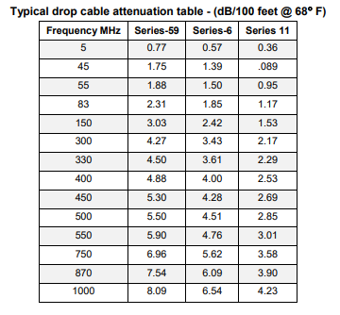
Calculating Drop Loss
With an understanding of the following fundamentals, you will be able to calculate what the proper signal levels should be at any given point in the drop system.
The calculation formula: Starting signal minus [(footage/100) x cable loss] equals predicted signal level.
• Starting signal − The starting signal depends on where you are starting from—tap, ground block, or splitter.
• Footage − The footage is usually estimated by stepping the cable or by making visual observation. The average length of an aerial drop is 75 to 150 feet. Note that the footage is divided by 100, because most attenuation charts are based on attenuation/100 ft.
• Cable loss − This will be found on the attenuation chart (previous page). Use the cable loss for the highest and lowest frequencies used in your cable system.
Example: Cable loss calculation
1. Select cable series (Series 6)
2. Select frequency (870 MHz)
3. Determine loss @ 870 MHz (6.09 dB)
4. Cable footage (78’)
5. Divide footage (78’/ 100) = .78 6. Multiply (.78 times 6.09 db) = 4.75 dB cable loss
DROP CERTIFICATION
Certification Process
Most of the installation work that you encounter in your daily routine will be working with existing drops. It is estimated that less than 5% of the installation work is new installs. This means that you will be reworking the existing drop to meet Mediacom standards and to certify that it works properly. All drops must be certified during installation or service call process. No exceptions allowed!
If drops are certified properly it will reduce the number of repeat service calls and service calls on installs leading to greater customer satisfaction.
Mediacom has established the following methods and procedure to enable certification of the drop. Do not skip any steps
Arriving at Job Site
1. Check for signal leakage as you approach service address.
2. Record levels if applicable.
At Customer’s Door
1. Verify with customer the reason for install or trouble call.
2. Provide customer a copy of the latest Pause Magazine and channel lineup card and any other available informational material.
3. Inform and discuss next steps with the customer.
4. Proceed to ground block.
At CPE
1. Request the customer direct you to each outlet.
2. Verify all outlet outputs are connected and terminated into Customer Premises Equipment (CPE)
At the Ground Block
1. Disconnect drop cable from input of ground block, inspect and replace F connector if needed.
2. Install 75-ohm terminator into the F-connector using a F81-splice.
3. Proceed to the tap.
At the Tap
1. If drop is aerial, visually verify drop is physically sound from ground block to tap. Drop must meet parameters set forth previously in this guide. Replace drop from tap to ground block if necessary.
2. Disconnect drop and visually inspect by checking for corrosion on interior of F-connector, blackened center conductor or water damaged braid. Water damaged braid or foil will appear as a powdery substance. Replace as needed. Always replace connector if it is not Snap N Seal.
3. Measure and verify output RF levels of tap port meet designed tap window parameters.
4. Note tap value and RF levels. If levels are not acceptable, use SRO request process to report any discrepancies.
5. Use your Field Strength Meter to measure and record any detectable noise in the drop. (Noise measured from drop connector back to termination at ground block.) If > -30 dBmV, replace drop from tap to ground block.
6. Apply thin coat of silicone grease to threads of tap port.
7. Connect drop to tap port and tighten appropriately.
8. Verify drop is tagged properly; if not, tag and record as needed.
9. Check for signal leakage. Repair as needed.
10. Proceed to ground block.
At Ground Block
1. Remove 75-ohm terminator from drop F-connector.
2. Visually verify ground block and SDU box meets parameters set forth in this guide. Verify drop bonded and ground tagged properly. Install, remove and replace or repair as needed.
3. Completely disconnect jumper between output of ground block and splitter network.
4. Apply grease to ground block threads and reconnect drop to input of the ground block. Tighten connector.
5. Connect SLM and verify ground block output RF levels are => +3 dBmV on all measured analog channels (FCC Specification). Levels should be appropriate for drop length.
6. Check and replace jumper cable and connectors from ground block to splitter network as needed. Apply grease to output threads of ground block, reconnect jumper and tighten connector. Leave input to splitter disconnected.
7. Proceed to splitter.
At the Splitter Network
1. Visually inspect all outlet cables attached to exterior of building. Remove, repair or attach as needed. 2. Verify splitter network meets the design parameters as previously indicated in this guide. HSD and Phone outlets should be designed so that they are split off before a house amplifier is added. (When possible use a directional coupler and its high loss leg to feed the modem).
3. Disconnect and inspect each outlet. Replace connectors as needed.
4. Grease output splitter threads. Reconnect and tighten connectors.
5. Connect SLM to input of splitter and check for noise on return path. (Note how outlets are configured to splitter network). − If no noise present, grease input splitter threads, reconnect jumper and tighten connector.
− If noise is present, isolate by disconnecting one outlet at a time from the splitter output port while checking for noise.ID outlets with noise and leave disconnected.
6. Reconnect outlets with no noise and tighten connectors.
7. Reconnect ground block to splitter jumper and tighten connectors.
8. Proceed to customer premise.
Back at the Customer Premise Equipment
1. Knock on door and ask customer to show you the location of each outlet. Explain next steps to customer. Verify CPE is working by having customer turn on the equipment.
2. Take the wall plate apart and inspect connectors. Replace and tighten connectors as needed.
3. Disconnect jumper, replace cable and connectors as needed. Reconnect jumper to wall pate output connector.
4. At jumper end feeding CPE, measure downstream RF signal levels at designated frequencies. (Must be => +0 dBmV, FCC Specification.) If levels are low: − Determine if there are additional splitter(s) in the line, remove or correct as needed. − If no additional devices found in line, reengineer drop using house amplifier if needed. − If no measurable RF signals present, indicates this is probably the outlet left disconnected at splitter network with return path noise problem. Verify by reconnecting outlet to splitter network and rechecking RF levels as stated above. o At CPE look for and replace any defective coax jumper cables or connectors used to interconnect customer equipment to our devices or cable. Verify noise corrected at input to customer equipment.
5. Connect RSVP meter to jumper end coming from wall plate and measure C/N level. (Measured level at input of each CPE must be => 31dB.)
6. Determine reverse transmit level at each device by using DCT or modem diagnostics. If return transmit level is too high or low, reengineer drop to correct problem.
7. Connect and finger-tighten all connectors to the input of DCT/HSD modem/eMTA/CPE and verify service working properly.
Wrap-up
1. Provide customer education including assurance services are working properly. If not working properly explain next steps to customer.
2. Complete and submit all required information
Passive Devices
Passive devices are devices that do not contribute energy to the signal as it passes through them. They do not require energy to operate. Taps, splitters, directional couplers, and traps are passive devices.
Taps
Taps are designed to reduce the input signal equally and distribute it to the available ports. The amount by which a tap reduces the signal is called the tap value.
NOTE: The tap value can usually be found on a colored sticker placed between the output ports.
Splitters
Splitters reduce the input signal by the amount indicated on the front of the splitter directly above the output port. Since the loss at higher frequencies is nominal, we can consider this a flat loss. The loss is the same for all frequencies.
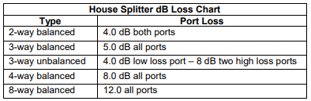
NOTE: The above splitter losses are based upon using the highest frequency (870 MHz), not what is listed on the splitters.
Directional Couplers (DC)
Directional couplers have two output ports, which reduce the input signal unequally.

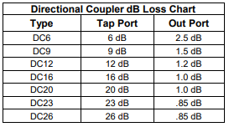
Using Splitters and Directional Couplers
A splitter/directional coupler is a passive device that splits RF signals. It is generally used to deliver service to multiple customer equipment locations. They are typically installed at ground block location or within building’s internal cabling network.
These devices have a specified amount of signal loss between input and output ports as designated by manufacturer. They have an equal amount of signal/power loss (flat loss) across entire bandwidth.
NOTE: Splitters/couplers must be capable of passing highest frequencies of system pass band.
When to Use Splitters/Directional Couplers
Splitters/couplers are typically manufactured in different configurations to accommodate the number of outlets requested by customers. (Use table on next page when deciding which one to use).
ENGINEERING DROP SYSTEMS
Caution: Before starting any new installation, the drop must be engineered properly. Use the following steps to calculate and engineer the drop system using Series-6 drop cable.
1. Starting levels, measure and record tap output levels for the highest and lowest channel used in your system.
2. Measure cable footage from tap to ground block location calculate and record losses for high and low channel. Minimum acceptable level at ground block is + 3 dBmV,
3. Select the correct splitter/DC based on the number of outlets requested and record flat loss(s).
4. Calculate and record drop losses for each outlet from ground block to the set top box/CPE. If calculated signal to input is less than +0 dBmV proceed to Step 5.
5. Determine if using Series-11 cable from tap to ground block will provide enough signal level.
COAXIAL CABLE
Coaxial cable, also referred to as “coax”, is available in a variety of sizes, depending on its use in network. Coaxial cable contains a center and an outer conductor. An insulator (foam dielectric) separates the center and outer conductors. The outer conductor may be encased in a plastic jacket. “Hard line” cables may not always have a plastic jacket and may be bare aluminum sheathed.
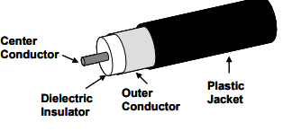
Coaxial cable is used in portion of network that distributes radio frequency (RF) signals from optical node to customer premises equipment.
• “Hard line” trunk cables are used in network running from optical node to amplifiers. “Hard line” feeder cable runs from pole to pole, pole to tap, or other line equipment.
• The smaller coaxial cable that runs from tap to customer’s house is the drop cable. The drop cable is routed to the house via messenger cable when routing in the air, and flooded cable when drop is buried underground. From output of ground block, standard non-messenger coaxial cable is then routed inside to customer premises equipment.
Types of Coaxial Drop Cable
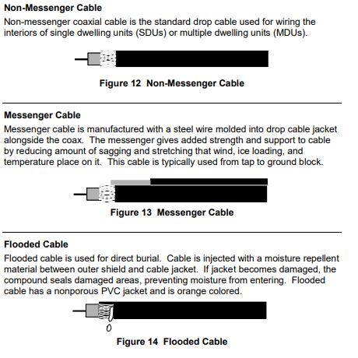
Drop Cable Requirements
Follow these company standards for drop cable.
• Use standard RG-6 or RG-11 cable, 100% bonded foil, 60% braid, Vrated cables as a minimum for all drop installations.
• Use only messenger drop cable for aerial installations from tap to ground block.
• Use flooded cable for all underground drop installations from tap to ground block. Use of orange-jacketed cable will help prevent accidental damage or cuts.
• Do not use flooded or messenger cable (exterior cable) inside building.
• Do not use colored non-messenger cable, typically white or beige, on exterior of building. It does not contain UV protection.
Drop Length
• Standard Drop Length – Use RG-6 cable for drops up to 150 feet or less.
• Long Drops – Coaxial drops that exceed the “standard” installation length are considered a long drop. Use RG-11 cable for all drops over 150 feet up to 250 feet (up to 450 with hot tap).
• In general, no drop over 250 feet in length should be installed unless hot tap has been engineered for increased output levels.
CABLE PREPARATION AND CONNECTORIZATION
Up to 90% of all trouble calls and 50% to 60% of all signal leakages in a cable network are caused by problems occurring between tap device and customer’s equipment. The majority of these service calls are the result of poorly installed cable connectors and/or poor connector types.
It is Mediacom’s policy that all non PCT drop connectors be removed and replaced with appropriate connectors.
Therefore, it is imperative that cable is properly prepared and connectors correctly installed.
Cable Preparation
A cable preparation tool must be used to prepare the drop cable for connectorization. The tool should be inspected regularly. Look specifically for nicks in the cutting blade, uneven cuts, or scoring of the center conductor. The manufacturer recommended timeframe to change blades is from 30-90 days.
NOTE: Under no circumstances should a razor/knife be used to prepare the cable.

Procedure for Preparing Cable
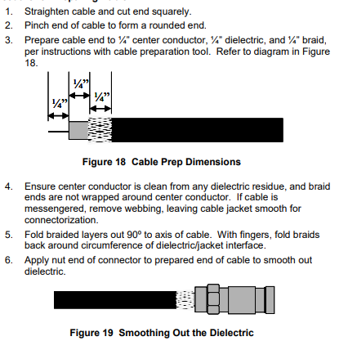
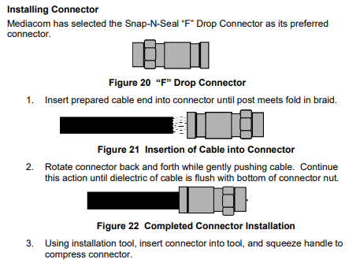

Weatherproofing Cable Connections
Mediacom requires using F-Seal to weatherproof connections of exterior cable. Although connectors may have a light lubricant coating, silicone grease must be used for added protection. The grease actually protects whatever the fitting is connected to, such as a ground block or tap port. F-Seal should be lightly applied to external threads of tap or splitter port to prevent corrosion. However, the center connector should never be bridged. Use F-Seal on all exterior connectors, or connectors in a corrosive environment. Do not use F-Seal inside the building. Place a dab of F-Seal small portion of threads. Screwing the “F” connector on the port will properly spread silicone grease/ F-Seal.
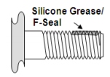
Properly Tightening F-Connectors
Over tightening of an F-connector may result in damage to female “F” port of a tap, drop equipment or Customer Premises Equipment. Under tightening of F connector may result in RF leakage or ingress, which can create problems in the forward and return path.
For the tightening procedures to be successful, it is assumed that the coaxial cable has been properly prepared and the F-connector installed correctly.
The following is a set of guidelines for properly tightening F-connectors. Abiding by these guidelines will reduce service calls and increase customer satisfaction.

There are three basic methods of tightening F-connectors:
• Finger tighten
• Torque wrench
• 7/16 Open-end Wrench or Universal Security Wrench

Finger Tighten
Use the finger-tighten method to tighten CPE female F-connectors and to start threading the F-connector onto female F-connector at the tap or any other drop equipment.
• Using fingers, thread F-connector onto the female F-connector. Take care to align threads to prevent damage; connector should thread easily. Note: If alignment is difficult due to location of connection point, spin nut backwards one turn to help with alignment;
• Tighten until nut stops. Post and cable should not rotate when F connector is adequately finger tightened.

Torque Wrench
Using a torque wrench is the preferred method for tightening F-connectors at the tap, ground block, and splitter or wall plate connections.
LRC recommends that the Snap N Seal F-connector be tightened to 25-30 inch pounds on all but Customer Premise Equipment (CPE). Mediacom uses torque wrenches that are set to 30-inch pounds
• Tighten F-connector finger tight;
• Use torque wrench to turn connector nut until the wrench clicks (breaks). Note: Do not continue to tighten after torque wrench clicks. Over tightening the connector will cause damage to threads.

7/16 Open-end Wrench or Universal Security Wrench
Use only when F-connector is inaccessible to using a torque wrench or if torque is not available.
• Tighten F-connector finger tight;
• Use an Open-end Wrench or Universal Security Wrench to tighten the F-connector nut an additional 1/6 turn (see following graphic). Turning point “a” to point “b” on hex head of the F-connect is equal to a 1/6th turn.

CAUTION: Over tightening the connector will cause damage to threads.
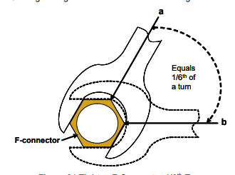

PRELIMINARY INSTALLATION STEPS
Starting the Job
Review Work Order
Before greeting the customer, technician should review all available information.

• First, review work order information about customer’s installation requirements. Although the information may be limited, it will still be important when discussing details of installation activity.
• It also is important to review products and services customer currently receives. Based on his or her current profile, determine what add-on products may interest the customer
NOTE: Make sure all tools and supplies necessary to complete the job are available before ringing doorbell.

Arrive on Time
The first step in the installation process is arriving on time for customer’s appointment. This is critical in demonstrating that customer is working with a professional and service-oriented organization.
Mediacom has instituted an “On Time Service Guarantee”. Customers are given a “time window” in which to expect technician’s arrival. The goal should always be to arrive within this window, aiding in achieving a higher level of customer satisfaction.

Late for appointment, notify the customer by calling directly or through a dispatcher. When talking to customer, take the following approach:
• APOLOGIZE for the inconvenience!
• Explain reason for delay.
• Discuss convenient time to reschedule work. (Only if necessary)

Customer Not Home If no one answers the door, contact the office so customer can be telephoned. It is possible that customer will not have heard knocking or the doorbell ring. Leave a “Sorry We Missed You” tag on the customer’s door.
(Any job not done must be approved by the supervisor BEFORE calling dispatch)

Greeting the Customer, Customer relation skills are important when working with customer. Foremost is establishing trust.

Greeting the customer in a professional and courteous manner begins with “Good Morning/Afternoon/ Evening”. Introduction should include technician’s name, name of company, and purpose of visit. For example: “Good Morning. My name is (first name only). I’m from Mediacom, and I’m here to provide your requested service.”

Good eye contact is essential to building rapport with customer. Removing sunglasses, looking directly at customer, listening intently, and speaking clearly convey to customer that technician cares.
Below are other customer relation skills to help create a positive impression of Mediacom and technician. This also will make the visit a more pleasant experience for both technician and customer.
• Communicate in a courteous and professional manner. Sound enthusiastic and helpful demonstrating a genuine concern for customer’s needs. Use words like “Please, May I, Thank you,” etc., as much as possible.
• Avoid using technical jargon and industry acronyms that may make customer feel uncomfortable.
• Be careful not to “blame” any Mediacom associates for errors on customer’s work order or mishandling of his or her account. Such behavior is unprofessional and will result in a dissatisfied customer – even if he or she is satisfied with work performed.
• Use customer’s name at least twice. A suggested approach is to use customer’s name when verifying account information. Another time to use his or her name in conversation is just before leaving, when thanking customer for his or her time and patience. Addressing a customer by name creates a friendly, professional atmosphere that fosters the perception of excellent service.

Dealing with Difficult Situations
Sometimes a technician may arrive at an appointment to find an upset customer. Maybe the technician arrived late for a rescheduled appointment, or customer could be frustrated with another Mediacom representative. No matter the source, it is important to calm customer.
In these situations, customer is generally looking for one or more of the following responses from a Mediacom representative:

• To be listened to
• To gain compensation/restitution
• To be taken seriously
• To have the employee who erred reprimanded
• Apology/empathy
• To get immediate action
• To be treated with respect
• To clear up the problem so that it never happens again

Following are some basic guidelines to assist in this type of situation. Individual professional style will determine what will work best.
• Listen − Let customer fully explain why he or she is upset.
• Empathize − Use expressions like “I can appreciate how you feel”, or “I understand your concern”, or “I know how frustrating it must be to you when cable service is out.”
• Probe − Ask questions to gain a full understanding of customer’s situation. Examples: “How long have you been waiting for us to install your service?” or “Tell me more about the communication problem you are experiencing with our office so I can resolve it.” or “What charges were you not aware of?”
• Take ownership − Personally offer to make sure the situation is addressed. This may involve service activity and/or special action that will ensure customer’s satisfaction. Example: “I will personally make sure that your first bill reflects the credit for the premium service that you did not order.”
• Apologize − Apologize for any perceived problems or miscommunication. Example: “I apologize for the inconvenience caused when we missed your original installation appointment.”

Above all, when trying to calm an upset customer do not blame the problem on other Mediacom employees. Although the problem may be resolved successfully, customer may continue to perceive that some of the organization is not customer oriented. Customers should always be made to feel that they would receive outstanding service at all times.

Verify Work Order
After introduction, verify customer’s account and work order information. This step will assist in learning the proper pronunciation of customer’s name and ensure that his or her account records are accurate. A sample verification of customer account information follows:

“May I take a minute and make sure that the information we have for your account is accurate? This is 123 Main Street and your name is _____? Thank you, Ms. Jones. I see that you currently receive our Basic package. Is that correct?”

NOTE: If a customer situation is urgent, and verification at beginning of visit is not appropriate, it can be done at the end.

Next, discuss work order with customer. If this is a new connect, survey the job site and explain to customer how cable will be routed and how drop will look on building. This will allow customer to visualize proposed route and express any concerns, or to design an alternate route if necessary. This also will help customer understand approximately how much time the job may take.

A thorough review of the work order will accomplish the following:

• Confirmation of services requested by customer - It is possible that the work order could be wrong. The intake person might have misunderstood the customer request. On the other hand, customer might have changed his or her mind since placing the order. Reviewing work order with customer can confirm that it reflects requested services and time needed to perform any additional work.
• Instilling customer’s confidence - Customers are often apprehensive when technicians need to gain entry to their residence. By knowing what procedures are needed to accomplish requested activities, and what areas of the building must be accessed, customer will feel more comfortable with the entire process. He or she also will be confident that his or her requirements have been accurately communicated and appropriate billing set up.
• Gaining customer’s cooperation and assistance - When customer is aware of procedures, logistics, and time involved, he or she may voluntarily provide information or assistance regarding anything that might impede work. For example, customer will know to take care of dogs or children who may pose a problem.

Sometimes when discussing work order or installation activities with a customer, it becomes apparent that the service he or she ordered is not listed. For example, the work order may show customer ordered basic service and two premium channels, HBO and TMC. However, customer actually wanted HBO and Showtime. If possible, complete installation per customer’s request. Afterwards, make sure all documentation turned in reflects changes made to work order. TIP: Always give customer a chance to communicate any concern he or she may have about the service.

Verify Customer Premises Equipment (CPE)
Locate customer’s equipment to verify it is in working order and cable ready. Mediacom requires customers turn on their equipment to confirm operation BEFORE cable is connected. As equipment becomes increasingly sophisticated and expensive, it is vital to establish that customer equipment works properly before proceeding. If problems exist, document it in writing.
Power up all the pieces of equipment at the same time to ensure there is no inter-reactivity interference
After verifying account and work order information and checking customer equipment, proceed with conducting a site survey.

Conduct Site Survey
If this is a new customer and building has never been wired, conduct a thorough site survey. When performing a site survey and planning installation, consider the following issues:
• Building features
• Location of customer equipment
• Location of pipes, electric wires, gas lines, dog fences, sprinkler systems, and other obstacles
• Distance of cable route from tap to customer equipment
• Appearance of cable route
• NEC/NESC specifications
• Customer’s desires
• Safety concerns
• Trespass issues (See following note).
NOTE: Permission must be obtained from owner before working on any private property. This is especially important when there is a need to access property adjacent to subscriber. Never open a gate without verifying presence of animals. Always request that animals be constrained or stored to protect all concerned. If property owner is not available, or permission cannot be obtained, work will have to be rescheduled. Tag door and follow not-at-home procedures.

CONSTRUCTION AND BUILDING FEATURES
It is important to remember that installation work will be performed on private property and in people’s homes. There are several important issues to consider, such as:
• What is the best way to route cable from pole or pedestal to the building?
• What is the best way to attach cable to exterior and interior of building?

A good understanding of general building construction is helpful when planning cable route and will provide the following benefits:
• Saves time.
• Installations will be neater, by using building’s features to make wiring less visible or by running the wire internally.
• Fewer mistakes or accidents will happen. For example, ceilings won't need patching because a step was taken in the wrong spot, or siding won't need replacing because of a hole drilled in the wrong location.

Styles and Types of Construction
Construction methods and materials vary widely from area to area. Local building styles are a reflection of climate, available materials, age of the building, building codes, terrain, cost considerations, and architectural influences. Ranch, split-level, and two- and three-story homes all have a great variety of exterior sidings. These exterior materials can include aluminum, vinyl, wood, stucco, stone or brick veneer, asbestos, or even asphalt. Buildings can be constructed with wood frames, concrete block, poured concrete walls, and other materials. Foundations can include basements, crawl spaces, or slabs.

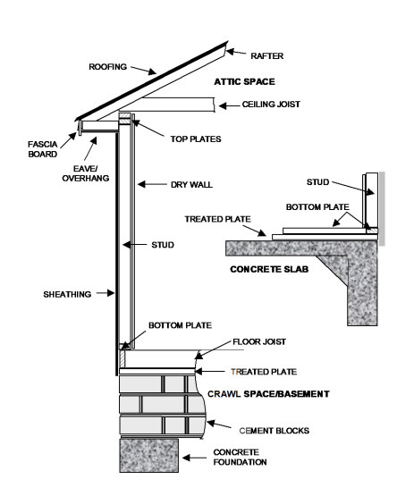
PLANNING CABLE ROUTE
Routing Considerations
Cable will be routed either aerial or underground to the building depending on how other utilities are routed. The cable will then be routed to outlet location using one of the following methods:
• Cable is routed directly to outlet locations using exterior surface of building.
• Cable is routed into basement or crawl space. Then it is routed to outlet locations through a hole in floor, or through inside walls using wall fish.
• Cable is routed through the attic. Then it is routed through closet to outlet location.

Discussing Route with Customer
Correctly routing exterior and interior cable is required for a proper installation. After observing site internally and externally, follow these steps.
1. Ask customer where equipment will be located.
2. Determine the exact location for each outlet.
3. Plan the cable route.
4. Decide where to drill.
5. Discuss cable route with customer.
If customer objects to the proposed routing, listen to his or her ideas on how it should be routed. Discuss but do not argue about any other possible routings. Try to route cable following customer’s specifications if it adheres to system policy. Nothing should be done to conflict with established safety or technical procedures. Contact Mediacom supervision if customer’s request cannot be met.

When discussing the project with customer, be sure to consider the following issues:

• Drilling
• Moving furniture

DRILLING GUIDELINES
Before drilling any holes, discuss with customer, because he or she may be able to tell you where pipes, electric wires, gas lines, or other obstacles are located.

Drilling Safety Guidelines
As in all aspects of technician’s job, safety is paramount. Follow these guidelines:
• Before beginning to drill through wall, always determine what is on the other side.
• Always wear work gloves and safety glasses.
• Before drilling any holes through a wall, check for items that may fall.
• Drilling is easier and safer if sharp drill bits are used.
• Always maintain control of bit’s speed when drilling by not using locking trigger feature on drill.
• Use light pressure and let the drill do the work. Do not push hard. Again, a sharp bit makes the job much easier.
• After drilling, be careful not to lay drill bit against anything that could burn or melt, such as carpeting. Caution – Tip of drill bit can be extremely hot after use.
• Use only double-insulated or battery-powered drill.

Drilling Through Walls and Floors
• There are two options for drilling an entry hole through the outside wall: − Drill from inside out (see Figure 28 on page 41) − Drill from outside in.
• Drilling direction is usually determined by type of material used on building exterior.
• Before drilling, survey exterior and interior entry and exit points.
• Keep in mind that a drill bit often breaks or splinters material when exiting. Using a sharp bit and light pressure can lessen this effect.
• When bit clears the first wall material, stop drilling and push drill bit through insulation to create a hole before drilling again. Drill through walls only, not the space between them.
• If there is a chance that material being drilled through contains asbestos, follow approved safety methods and procedures.
• Use a shop towel, newspaper, or other material to catch debris that falls when drilling. Offer to use customer’s vacuum to clean up.

Guidelines for Drilling from Inside
• Make sure measurements are accurate and made from a good reference point – for example, from inside corner of window or door. Placing a small piece of tape on window as reference will aid in measuring inside and outside locations.
• Make sure there is enough clearance in all directions to allow for slight measurement errors.
• Always drill hole and mount the wall plate at same height as electrical outlets.
• When drilling through a floor, drill as close to the wall as possible allowing space to miss the tack strip. Do not drill directly through carpet. Cut a small X in carpet before drilling and use small copper tubing or conduit to shield bit from snagging carpet fibers/backing.
• Do not drill through baseboards or hardwood floors.
• Do not drill through woodwork or wall where there is a “pocket door” (a door that opens by sliding it into wall cavity, hiding it from sight).
• When drilling from inside to outside, be sure of exit point. Watch for pipes, telephone lines, gas meters, electrical circuit panels, etc.

The figure below illustrates drilling from inside to outside. Aim the drill and bit at a slight downward angle. Measurement between entry and exit holes should be less than an inch or about a 5° angle. This will help prevent water from following cable into the building. Exterior hole should always be lower than that on interior.

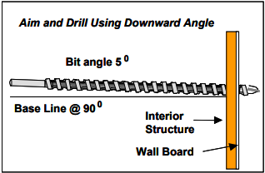

Guidelines for Drilling from Outside to Inside
• Use correct bit for the type of siding (wood bit through wood, vinyl, and aluminum siding; masonry bit through mortar, cinder block, etc.).
• If building has wooden exterior siding, it is generally better to drill from inside to out.
• For buildings with exteriors like brick, shingles, stucco, and tile, drill from outside to in using softer mortar as drilling point. If for some reason drilling must be inside to out, be sure to use a light touch. Exit hole may be quite large if extreme care is not used.
• Only use a hammer drill setting when drilling through brick or cement.
• When drilling hole through exterior wall from outside, make sure it is drilled at a slight upward angle from outside to in.
• Do not drill a foundation wall without prior written approval from Mediacom supervision.
• When drilling from outside into a basement or crawl space, drill through header joist located between floor and foundation wall. Use utility (power or telephone) or water and gas pipe entrances as a reference point.

MOVING FURNITURE
Follow these guidelines if furniture needs to be moved in order to install outlets or connect cable
• Ask customer to move it unless individual is disabled, elderly, or unable to move furniture. • Do not move furniture if it is too heavy for one person to lift. • Before moving any piece of furniture, have customer remove anything on it. • Do not drag furniture with legs.

AERIAL INSTALLATIONS
Overview of Routing Cable from Pole to Building
Careful planning is critical for aerial installations. The longevity, serviceability, aesthetics, and performance of drop are determined by quality of installation. Aerial cable must be properly placed and attached at pole and house. Remember that both aspects are important when planning how to route drop. A few general rules of thumb are as follows:

• Keep drop run as short as possible.
• Follow power service lines whenever possible.

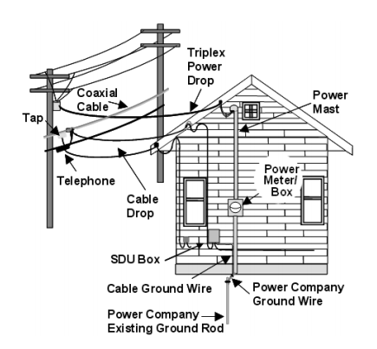
Drop Routing
Once location of Single Dwelling Unit (SDU) enclosure/ground block has been determined, plan the cable route. Keep in mind the following issues:
• Location of other utility drops (power and phone)
• Outdoor lighting lines
• Drain pipes from downspouts
• Trees or bushes
• Location of swimming pools
• Property lines
• Type of exterior structure

Aerial Drop Routing Guidelines
Follow these guidelines for routing an aerial drop:
• Maintain proper clearances from other utilities and over roads, walkways, and other structures. See illustration as shown in Figure 31 next page and in Addendum B.
• Drop should follow power service line as a first choice. Observe if power service line is underground, aerial, or a combination of both. Also, note how phone service line is routed. Never use same attachment as power or telephone. Do not attach to power mast.
• Do not attach drops to trees or other foreign objects.
• If attaching to a service or stub pole, record pole number and report it to Mediacom supervision or management. These pole numbers are reported to pole owner for billing purposes.
• Look for any obstacles between the pole and building, such as trees, power lines, swimming pool, trampoline, or swing sets. Plan how to route around them.
• Avoid routing through trees. Rubbed holes from a tree limb or a squirrel chew in protective jacket of cable will allow water to deteriorate conductors, resulting in signal leakage and signal loss.
• Do not route across neighboring property lines. This “aerial trespass” must be avoided. (See Figure 30 on next page). Use a mid-span attachment in these situations. If you cannot provide a good route, even by using a mid-span drop, call supervision.
• Determine which pole will service customer.
• Observe pole and plan how best to reach working area.

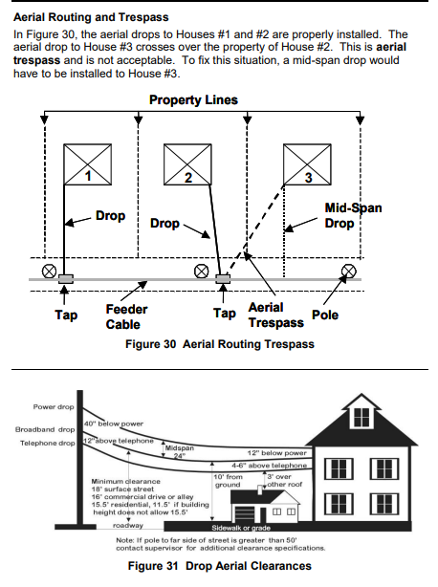

Minimum Climbing Space
If any utility maintains wires above Mediacom’s cable, drop must be attached in a manner that does not obstruct climbing space on pole. Climbing space is defined as an unobstructed vertical space 30 inches square, along either side of pole. It may be on strand side or opposite of pole.

NOTE: This space allows for safe climbing using ladder or gaffs. Follow Mediacom’s safety procedures and guidelines on safe climbing.

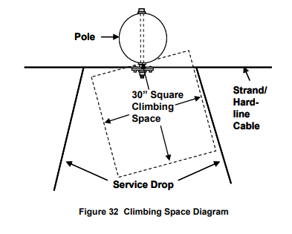
Span Clamp Attachment
Use a span clamp (Q type), also referred to as a drop clamp, to attach and secure drop to strand. Follow these guidelines for mounting span clamp and attaching messenger coaxial cable to strand.
• Check for electrical hazards starting at ground level and all the way up to strand.
• Attach a span clamp to strand no closer than 6 inches beyond hard-line connector of tap or amplifier, and a minimum of 15 inches from center of pole. These distances allow space for any future work, and for others to climb pole safely.
• If it is necessary to mount another span clamp on the strand, place it no closer than 6 inches from existing clamp.
• Attach span clamp in expansion loop area, whenever possible. In this area, cable is away from strand.
• Always place span clamp with open-end facing down.
• Never attach span clamp to anything other than strand.
• Do not attach a span clamp over lashing wire. Mount it in gaps between wraps.
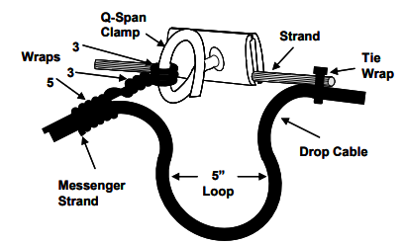
Messenger Tie-Off Method
Use designated tie off method to secure messenger cable to J-hooks, span clamps, and P-hooks (building hooks). Mediacom recommends using the 3-3-5 tie-off-method. The 3-3-5 tie-off-method is illustrated above.
Follow these steps for tying off messenger wire cable.
1. Remove 3 feet of messenger wire from cable.
2. Separate 15 inches of messenger wire from cable.
3. Wrap messenger wire around device three times.
4. Next, wrap messenger wire around itself three times.
5. Then wrap messenger wire around cable five times.
6. Cut off excess messenger wire.

Forming Service Loops
Service loops provide surplus cable in case it will be needed in the future. Create a service loop in the coaxial cable at:
Q-span clamps J-hook at the pole P-hook at building
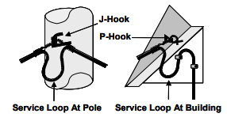

J-Hook Attachments
If drop is connected to last pole with strand, a J-hook may be used instead of span clamp to attach cable. Drive J-hook into pole, open side up, facing the building at strand height. See Figure 34 above showing J-hook at pole. All J Hook attachments are to be treated the same as a new pole contact. Attachment must be reported to pole owner.
If more clearance is required over streets and driveways, select a higher location on pole to place J-hook. Use this technique only where adequate clearance exists (30 inches from power neutral or 40 inches from energized power conductor). Do not use staples in place of drive rings to attach cable vertically. Never use telephone or power attachments, or other equipment not owned by Mediacom. Caution: Wear safety glasses while installing J-hooks or drive rings.

Cable Attachment to Strand/Feeder Cable
Follow these guidelines for attaching messenger cable to strand:
• Tie wrap drop to underside of strand and feeder cable.
• Do not tie drop to top of strand or pole hardware, because squirrels may chew it. Follow strand when feeder cable expansion loop is encountered.
• Do not attach drop cable to expansion loop.
Figure 35 shows tap on strand about 18 inches to right of pole. Drop cable on the right is attached at span clamp 24 inches from pole, and connected to tap about 6 inches away from clamp.
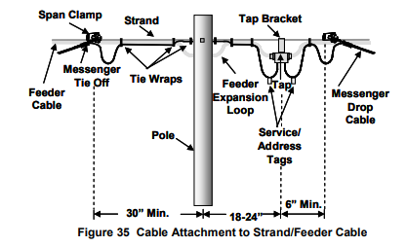
Attaching to Opposite Side of Pole
Follow these guidelines for attaching cable to span clamp located on opposite side of pole from customer tap:
• When attaching drop cable to opposite side of pole, leave a 5-inch minimum diameter service loop at tap and span clamp.
• Use tie wraps to attach drop to feeder cable between tap and span clamp.
• Never leave the drop hanging loose.

Mid-Span Attachments
Avoid mid-span attachments if possible. Install mid-span only in these situations:
• If trees, swimming pools, or other objects are in the way
• When you cannot maintain proper clearances from telephone and power wires
• If property lines will be crossed, (See Figure 30.Aerial Routing Trespass).

It is best to follow utility lines when possible, while maintaining proper clearances. The proper way to run drop using mid-span attachment is to run cable from tap to mid-span clamp and then to building. Tie wrap drop every 2-4 feet between span clamps.
There is a very important reason for not running cable from the building first, then to the mid-span point. When ladder and technician’s weight are removed from strand, the drop will be either too tight or too loose. In addition, if drop breaks free from the building, it poses a serious safety risk – releasing tension on strand could throw ladder and technician.

Guidelines for Mid-Span Attachments
Follow these guidelines for running a drop using a mid-span attachment after completing attachments at the tap.
• Run cable from tap to mid-span attachment and last to the building.
• Maintain proper clearances; ensure drop does not contact utility lines, tree branches, etc.
• Make sure hook on span clamp is positioned so that messenger from drop will not slip off.
• Ensure that drop between span clamp at tap and mid-span clamp hangs no more than four inches below strand. Tie wrap drop every 2-4 feet between clamps.
• Always remove drop from building first, when mid-span drop is being replaced.

Connection at the Tap
Customer tap is a device that allows cable signal distribution to several buildings. It is attached to the strand and has at least two connection ports, but may have as many as eight ports.

Inspect tap before connecting drop. Use the following guidelines to make connection.
• Check for cracked or broken cable.
• Use Signal Level Meter (SLM) to verify proper RF levels. It must be a minimum +10 dBmV on any channel, unless system has other requirements.
• Clean tap port thoroughly if dirty or corroded.
• Check for broken tap ports, excessive corrosion, or damage at tap. Indicate on work order if there are broken or damaged tap ports. Tap plate will need replacing.
• Terminate any ports not having system-approved terminator.
• Check for signal leakage.

DROP TAGGING
All drops must be properly tagged in order to avoid confusion about which cable serves which subscriber. Not tagging causes mistakes in servicing the customer and requires additional time to identify the correct drop. The objective is to improve efficiency and reduce theft by standardizing our drop tagging methods and procedures.

Service Level Tags Service level audit tags are to be placed on the bottom of the drop drip loop at the tap or approximately five inches away from the drop connector.
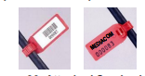
Any change in the customer account status will require the appropriate change in Service Level audit tag.
• Verify current Service Level audit tag matches customer listed tagging information.
• The current Service Level audit tag must be removed and replaced with a new Service Level audit tag.

The same tagging procedures will be used for residential and commercial accounts. Service Level Tags are color-coded based on their functionality.
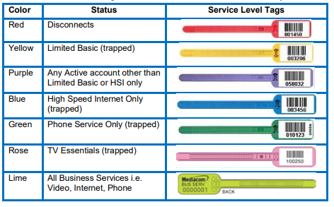
Phone Service Marker
Use an Orange Wire Marker” to identify phone customers with a multiple service
Place the “Orange Wire Marker” on the bottom of the drop drip loop next to the “Service Level Tag” facing away from the tap.
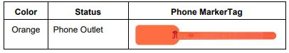
Ground Wire Tag

All ground wire is to be identified with a designated special purpose “Ground Wire” tag.
• The Ground Wire Tag is to be placed at or within five inches of the common bond point device (clamp/strap/split bolt/acorn).
• The installer is responsible for tagging new and/or any existing ground wire not properly tagged.
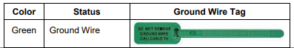

Address ID Tags
• The installer is responsible for properly tagging each drop with the appropriate address ID tags.
• Each drop is to be tagged with the last two digits of the address. Example: 7624 Maple Street would be tagged “2” “4”.
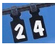
• Address tags are to be placed two inches after Service Level audit tags.
• Any drop feeding an MDU/Condominium from an underground pedestal or aerial tap must be properly identified with an “AP” address tag.
• Attach one “AP” tag at the tap and one inside the MDU enclosure just before the splitter network.
• When tagging addresses at an MDU/Condominium use the unit number to identify the address, example: 1234 Maple St. Apt # 14 would be “1”
• If the MDU/Condominium has units with the same last two digits tag the drop with the complete unit number, example: Apt. # 104, 204 or 304 would be “104” etc.
• If the individual unit has multiple drops feeding different locations within the unit, use the following identification scheme. In this case the technician is to use the alphanumeric method utilizing both letters and numbers. First, bundle all drops for the specific unit with zip-ties and tag the bundled drops with the appropriate unit number. Second, tag each individual drop in alphabetical order as follows: A—Living Room, B—Master Bedroom, C—Second Bedroom.
• Letters are available A through Z.
• When the MDU/Condominium uses a letter to identify the unit, as in the case above, tag the bundle with the appropriate letter and identify the individual drops numerically. 1—Living Room, 2—Master Bedroom, 3— Second Bedroom.
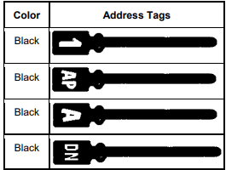

Installing Tags
Installing Tag Steps
1. Verify address and service level listed on the work order.
2. Select correct tag(s)
3. Record tag number if installing service level tag (scan with hand-held
device)
4. Wrap tag's tie-wrapped end around cable and zip tight.
5. Cut excess tail off tie-wrapped end.
6. Properly dispose of cut end.

ATTACHING CABLE AT BUILDING
Installing P-Hook
The first step in attaching cable at building is installing a “P” type drop hook, which is a threaded hook used as attachment point on building. It is properly positioned with flat side down and curved side facing span clamp, providing maximum strength at hook shaft. Install hook into a structural member if possible. (See Figure 38 below)

Follow these guidelines for installing P-hooks to buildings.
• Screw P-hook into building. Do not hammer it in.
• Always install P-hook into stud or other strong support wood.
• Locate point where fascia board is attached to rafter and/or ceiling joist. Use this location to install P-hook. Never install P-hook into fascia board only. In time, this will pull board or hook off building.
• Avoid screwing P-hook directly into vinyl or aluminum siding. Stress applied by drop cable may pull siding off building.
• Locate P-hook near other utility attachments, maintaining proper clearances, a minimum of 12 inches below power wire and 4 inches above telephone wire.
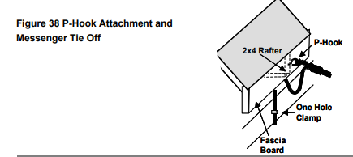
Cable Sag
After P-hook is installed on building, sag the drop cable and attach to P-hook, using messenger tie-off method. Refer to Figure 39 below to determine the allowable sag from pole to P-hook. Cable sag between span clamp and midspan clamp or mid-span clamp to building cannot exceed more than 6 inches for every fifty feet.

Pay attention to the sag of electric and phone lines. If possible, drop should have similar appearance when sagged.
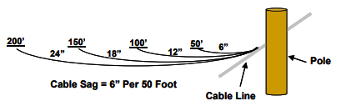

Attaching Cable and Equipment Overview
Once P-hook is installed and cable sagged, cable is then routed to drop enclosure, where it is connected to ground block and/or splitter.

An SDU drop enclosure is a box mounted to exterior wall of building, similar to that used by the telephone company. It creates a professional appearance, weather protection, and service control and offers a common demarcation point.

Ground block and ground/bond wire are used to route potentially dangerous currents (from lightning strikes or power surges) safely to a common ground electrode, protecting people and/or equipment.

NOTE: The National Electric Code (NEC) requires drop be bonded to building’s common bond point. Ground wire should be routed as straight as possible and no more than 20 feet in length. Reminder: Secure ground wire appropriately.

A splitter is a device that allows for connection of multiple pieces of customer equipment. The more times RF signal is split, the weaker it becomes.

Figure 40 illustrates cable attachment at building. Drop is routed from a P-hook, attached to side of building with clips/clamps, and connected to ground block in SDU enclosure.

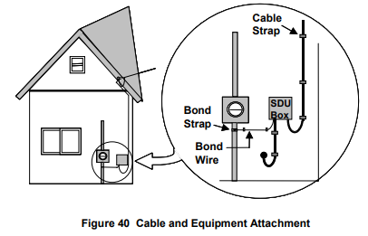

Bending Drop Cable
Coaxial cable must be treated carefully. Rough treatment or bends that are too tight can damage cable, resulting in low signal levels, ghosting, and/or signal leakage. Follow these guidelines when running exterior or interior wires:
• Always make gradual bends in coaxial cable.
• When forming drip loops, make a 5-inch diameter loop at the ground block and splitters. Make a 2½-inch radial bend when going around corners. These are minimum bending radii. Make a 5-inch diameter (2½-inch radius) bend to ensure cable will not be damaged. The minimum radius should be at least 10 times the cable's diameter.
• To easily measure loops and bends, form a fist and loosely wrap the cable around it. This will measure approximately 5 inches. Try to make all loops the same size to ensure a more professional appearance.
• When forming a bend around corner, place your hand between corner and the cable, forming bend in cable around your hand. This will provide an approximate radial bend of 2½ inches.
• In addition to the 5-inch drip loop at entry hole, make a small bend at entry point into building. Leave enough space to place two fingers between sides of building and the cable. The cable should not lie flat against the building – by leaving enough space for two fingers, the bend radius will not be compromised.
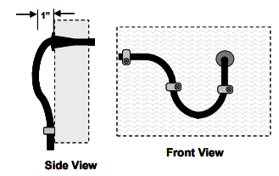
Guidelines for Attaching Cable to Building
Follow these guidelines for attaching drop cable to the building.
• Do not attach drop cable to other service utilities, rain gutters, or down spouts.
• Do not allow drop to rub against building, trees, or other obstructions. Over time, continued rubbing can cause damage to jacket or braid, and possible unseen damage. This could result in ingress, egress, and signal quality problems.
• Do not run drop cable diagonally on building.
• Support cable with cable clamps or plastic siding clips every 18-24 inches horizontally, and every 3 feet vertically. Do not place clamps or clips within 2 inches of corner.
• Attach cable using appropriate metal clamps on building exterior made of brick, stucco, cinder block, or decorative stone. Attach clamps using plastic anchors with screws placed in mortar joints.

Mounting SDU Drop Enclosure
The SDU drop enclosure is a tamper-evident box that is mounted to an exterior wall. A mounting grid inside the enclosure provides for easy attachment of equipment. The system determines type of equipment used. It also depends on services/products customer subscribes to and number of outlets. (See Figure 42 for illustration).

The enclosure can be mounted to most types of building surfaces. It also can be mounted to a pipe or post in situations where it cannot be mounted to wall of existing structure. Most mobile home sites use a post for mounting ground block/enclosure (See Figure 27 on page 37).
Follow these guidelines for mounting SDU drop enclosure:

• Mount SDU enclosure on building at ground block location, at least one foot from utility meter/breaker box, or as close to common bond as possible. Placing enclosure and ground block near power-service meter panel will ensure proper bonding and grounding of cable.
• Mount drop enclosure at about same height as other service enclosures. They are usually 4-5 feet above ground level.
• Avoid installing SDU enclosure at locations where water drains off the roof.
• Secure the cover to the base by using an orange colored “Budco” tag. Helps prevent theft of service and entry of rain, bees and hornets.
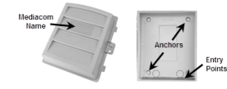
Procedure for Mounting Enclosure

1. Pick location for mounting enclosure.
2. Locate 4-5 feet above the ground level, minimum of 1 foot from power
equipment.
3. Drill out two knockouts in feet of enclosure. Use top right and bottom
left. Using all four “feet” will twist box and cause improper fitting or
sealing of lid.
4. Level the enclosure, using a level.
5. Mark locations of holes, using enclosure as a template.
6. Drill holes in building for anchors and screws.
7. Secure enclosure to building, using appropriate fastener for type of
surface.

Cable Insertion
Use the entry points at bottom of the enclosure to insert drop cables and ground wire into box. Insert wires by penetrating through the precut locations in the seal located on the bottom of the enclosure. Do not discard the seals they offer protection against wasps and other critters entering the enclosure.

Cable Bending Radius
Coaxial cable must be treated carefully. Rough treatment or excessive bending can damage the cable resulting in signal impairments including low levels, ghosting and signal leakage/ingress.

Use gradual bends when forming loops in the drop cable that will be placed in the SDU enclosure. The recommended minimum bending radius is 2/12 inches, which is equal to a 5-inch diameter loop. Tip: To easily measure loops and bends, form a fist and loosely wrap the cable around it. A fist will typically measure approximately 5-inches in diameter.

Preparing and Place Cables Other Equipment
After properly engineering and routing the input and outlet cables and ground wire:
• Insert cables as described above
• Form loops and cut to proper length (leave a little excess for future connector replacements). • Install connectors
• As engineered, interconnect cables to the ground block, splitter network and house amplifier if needed
• Connect ground wire to the bond point

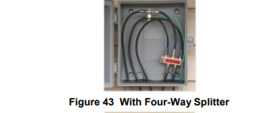
Replacing Existing SDU Enclosure
Existing enclosures should only be replaced if they are of any other type than Mediacom current issued SDU.
NOTE: If new holes need to be drilled, the old ones need to be repaired before attaching the new enclosure. Use silicone sealant to fill the holes.

GROUNDING AND BONDING
What Is A Ground?
A ground is a connection to earth or a conductor serving as earth potential. When a local power company installs its service, it ties the neutral line to a metal rod driven into the earth. This ground rod is a copper clad or galvanized steel rod, usually eight feet long and 5/8 inches in diameter and driven into the ground. It is also referred to as the power service electrode.

A ground can be intentional or accidental. A network is “effectively grounded” when intentionally connected to earth through grounding connection(s) of low impedance and when having current carrying capacity to prevent voltage buildup. Ground wire must be insulated, made of copper (or other corrosion resistant conductive material), and be appropriately sized according to the NEC

An “accidental” ground is an unplanned temporary path that current takes. An “effective” ground can protect circuit or network, but an “accidental” ground may damage the network or injure people.

What Is A Bond?
A bond is the interconnection of different ground conductors made by using a bonding conductor. Two or more electrodes that are effectively bonded together are treated as a single electrode system to limit voltage differences between respective wiring systems.

Purpose of Grounding and Bonding
Systems and circuit conductors are grounded to redirect voltages due to lightning or line surges to the earth-grounding electrode.

The purpose of bonding the drop cable is to limit potentially lethal currents that may be present from external sources such as electric power lines, downed poles, or lightning strikes. Bonding equalizes electrical potential between conductors. Equalizing potential voltages eliminates electrical flow. Utilities at customer’s premise must be bonded to equalize any voltage that might appear.

Drop Grounding Protection

All drops must be grounded. Drop must be grounded before any splits or other connections are made. Use only UL approved products to ground drops. No equipment shall be used for grounding unless approved by MEDIACOM Corporate Engineering Department.

The outer conductive shield of the coaxial cable must be grounded at the premises as close to point of cable entrance or attachment as practicable.

NOTE: Selecting a grounding location to achieve the shortest practicable grounding conductor helps limit potential differences between Mediacom and other utilities.

Grounding Wire - use only approved insulated ground wire.

Size - ground wire shall not be smaller than 12 AWG. It shall have a current carrying capacity approximately equal to that of the outer conductor of the coaxial cable. Grounding wire shall not be required to exceed 6 AWG.

Length - in one and two-family dwellings (SDUs), ground wire shall be as short as practicable, not to exceed 20 feet in length. Exceptions: (see Bonding and Grounding Mobile Homes)

Run in Straight Line - ground wire shall be run in as straight a line as practicable.

Grounding and Bonding Single Dwelling Units (SDUs)
Use the following methods for grounding and bonding SDUs. Option #1 is required before using option #2 and option #2 is required before using option #3 and so on. (See Figures 45-47)

Option 1- from ground block location, route ground wire to the existing power companies externally provided 6 AWG copper ground wire stub. Bond ground wire to power’s 6 AWG ground wire using a #6 split bolt connector. (See Figure 45).

Option 2- from ground block location, route ground wire to the existing power company’s grounding electrode (ground rod). Bond ground wire to power’s ground rod using a Mediacom provided acorn clamp. (See Figure 46)

Option 3- from ground block location, route ground wire to the existing metallic conduit between the load side of the power meter and the input side of the service disconnect cabinet or circuit breaker box. Bond ground wire to the metallic conduit using a galvanized pipe-bonding strap. Remove paint, rust and corrosion from the conduit before attaching bonding strap. (See Figure 46)

Option 4- from ground block route ground wire to the power meter box. Bond ground wire to power meter box using meter box ground strap. Before installing clamp, apply a dab of silicone grease to the contact points of the bolt and the steel points on the slotted bracket. (See Figure 45)

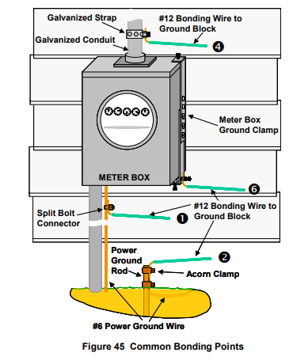

UNDERGROUND INSTALLATIONS
Overview Routing and Burying Drops

Like aerial installations, careful planning is just as important for underground installations.

In an underground installation, the drop cable originates from feeder network that is buried and accessible at tap located inside pedestal. Drop is run underground from pedestal to the building in one of two ways:

• Directly buried into ground
• Installed in conduit that is buried in the ground

The drop is connected using same process as aerial drops. Occasionally the drop may originate as an aerial installation. In this case, drop is run down pole and buried from pole to building. Figure 48 illustrates an underground drop from pedestal to building.

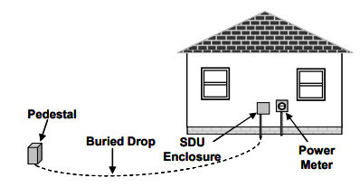
The following guidelines will assist in planning underground installations:
• Determine if drop is already installed with or without conduit.
• Determine location of pedestal or vault.
Trespass issues – Follow the same guidelines as for aerial trespass. Instead of using aerial mid-spans to avoid trespass, underground drops must be routed in a utility easement. An easement provides the right to use land for a specific purpose, regardless of ownership. Utility easements allow Mediacom to run underground cables. Drop cable must be routed in utility easements to avoid trespassing. Be sure you route the drop to point where cable crosses customer’s property and then to the building.

Conducting Underground Site Survey
• Find location of nearest tap to be used in connecting customer’s drop.
• Locate building common ground and plan route of drop and enclosure/ground block location. • Locate logical entry point into building based on location of customer equipment.

Identifying and Avoiding Obstacles
Identify and avoid any obstructions that may be hidden or cause a problem with routing drop cable. Listed below are some obstacles to avoid:

• Power lines, telephone lines, or other coaxial cable
• Sprinkler system lines – Customer is responsible to locate
• Sidewalks and driveways
• Outdoor lighting wires and dog fence wires – Customer is responsible to locate • Swimming pools
• Gardens, flower beds, and landscaping material
• Gas lines • Sewer and water pipes (usually well below 8 inches)
• Rocks and tree roots

Unburied Drops
A diligent effort must be made to promptly bury all underground drops, by either direct burial or placement in conduit. Follow system specific guidelines and procedures

The following guidelines apply to most systems:
• When drop is not buried for any reason (including inclement weather), ask customer to sign a drop burial acknowledgement before laying temporary drop.
• Do not place drop if customer does not sign acknowledgement.
• Run underground cable along existing fence line or other route that minimizes potential for risk of third parties tripping or entangling themselves. Never lay drop across pedestrian walkways or traffic paths.
• If not possible to run along fence lines or locations that prohibit pedestrian traffic, mark drop according to system practices.
• Always leave enough excess cable to ensure it can be used for buried drop. If cable is too short, it will be thrown away – wasting valuable resources.
• Inform building owner/customer of temporary cable location and drop burial process.
• Document and report temporary drop status as soon as possible. Each system has methods/procedures for tracking unburied drops.
• Weather permitting; drop burials are usually completed within 14 working days. If not buried within 14 days, customer should be contacted and informed of new date.

Connecting Drop at Pedestal
Use the following guidelines to connect drop
• Perform a physical inspection. Open pedestal and clear pests such as bees, wasps, mice, spiders, fire ants, snakes, etc.
• Check location of existing drops and feeder cables.
• Check for electrical hazards.
• Check for cracked or broken cable.
• Check for broken tap ports, excessive corrosion, or damaged tap. Indicate on work order whether there are any broken or damaged tap ports.
• Thoroughly clean tap port threads if dirty or corroded.
• Use SLM to verify proper RF levels. There must be a minimum of +10 dBmV on any channel, unless system has different requirements.
• Install connector on drop cable and connect to tap.
• Terminate any ports not already terminated.
• Document signal leakage
• Replace pedestal cover and secure with locking device.
• Thoroughly clean and pick-up area

NOTE: Buried drop must be inserted beneath bottom of pedestal rather than through pedestal cover.

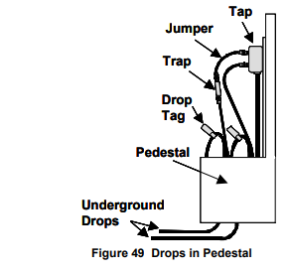

Underground Drop Attachment at Building
Follow these guidelines for routing and attaching cable from where it exits ground to enclosure/ground block location.
• Where cable exits ground, use small conduit or “U” molding (a plastic or PVC covering that is open on one side and designed to cover drop) to protect the drop. Molding should extend a few inches below ground level and up side of building extending into the SDU box. Attach molding to building with at least two clamps appropriately secured using screws and anchors. This will provide protection from mowers, weed eaters, garden tools, children, and pets.
• If drop is installed in conduit, a 90º sweep should be used to extend conduit above ground level. As needed, add additional conduit and appropriately attach. Once cable is in place, seal end of conduit.
• If point where cable exits ground is not at or near same location as ground block, cable can either be buried along base of foundation (preferred method) or routed and attached with fasteners alongside of building.
• Leave a 5-inch drip loop at ground block.
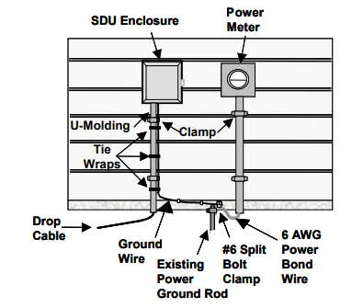
AERIAL TO UNDERGROUND DROP TRANSITION
Aerial Tap to Underground Drop

Use the following guidelines when routing and installing drops from aerial tap port to an underground drop.
• Design drop and select appropriate sized underground drop cable.
• Starting at contact point of dwelling setup cable caddy and pull cable to pole. Pull enough excess cable to allow for proper routing and burying of cable plus amount needed to reach aerial tap. The objective is to run entire drop from tap to ground block with no splices in the cable.
• At pole slide approximately 25’of the underground drop cable through 6’ piece of flex duct in preparation for connecting drop to tap port.
• Connect underground cable at tap using Connection at Tap guidelines pages 51-55.
• Route the drop down back quadrant of pole as shown in Figures 51 and 52.
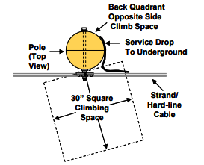
• Attach drop to pole using clamps screwed into pole and spaced approximately 24 inches apart. Start at top and work your way down reversing clamps as shown in Figure 52. Maintain straight line down the pole.
• Cut and remove sod if applicable to enable digging hole 6-8’’ deep. Place flex duct in hole as shown on Figure 52. Attach flex duct to pole using two-hole straps screwed into pole or with appropriately sized copper staples hammered into the pole.
• At end of flex duct protruding into the ground pull any remaining slack from drop running down the pole.
• Back fill and tamp soil into the hole using caution not to damage drop cable. Replace sod and cleanup area before leaving pole location.

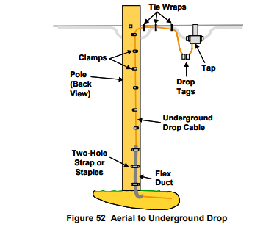
• Follow guidelines for “Underground Drop Attachment at Building” as outlined on page 75

Pole Install
Use the following steps to install ½” u-guard at pole location:
1. Dig a hole approximately 6 inches deep where the drop exits ground.
2. Typical use is to cut u-guard to a 4 foot length that will extend from 6-8
inches below ground level as shown on following figure. NOTE: Local
codes may require covering the drop from ground to strand level.
3. Place u-guard over the drop and attach to pole using staples or clamps
approximately every 24 inches
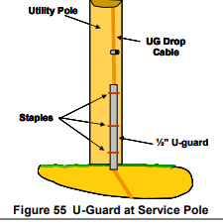

ROUTING AND WIRING INTERIOR OUTLETS
Interior Wiring
Techniques for Routing and Wiring Outlets
There are three ways to route cable from ground block/splitter location to the outlet.
1. Cable is routed directly to outlet locations using exterior surface of building.
2. Cable is routed into basement or crawl space, and then routed to outlet locations through a hole in floor.
3. Cable is routed into attic and then routed through closet to outlet location.

Routing Cable to Outlet on Exterior Wall
All outlets must be installed with a continuous “home-run” drop (no splices or splits) from ground block/ splitter or a central or secondary split to equipment input.

Follow these general guidelines for routing cable on exterior surface:
• Do not attach cable to other utility wires.
• Do not attach cable to rain gutters or down spouts.
• Never run cable over roof; through gutters or downspouts; or down chimneys.
• Do not cross skylights, doorways, or stairway openings.
• Route cables in straight lines vertically or horizontally. Never run cable diagonally.
• Route exterior cable, hiding it as much as possible and ensuring visible cable is aesthetically pleasing. Use features of building to conceal cable; for example, routing cable beneath exterior ledge or overhang will make it less visible.
• Attach to surface of building every 18-24 inches horizontally, and every 3 feet vertically. Use appropriate clips and clamps as discussed in Guidelines for Attaching Cable to Building on page 59.
• Drill through wall and mount wall plate at same height as electrical outlets. (See DRILLING GUIDELINES on pages 39-41.)
• Leave enough cable behind equipment to reach half a wall length or a maximum of 8 feet. This will give customer enough cable to move equipment.
• If equipment is moved necessitating that cable cross a doorway, it is suggested that another outlet be installed rather than a longer cable.

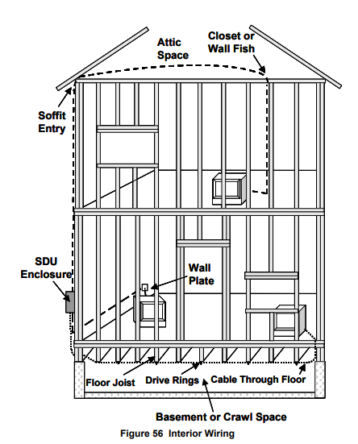

Routing Through Crawl Space
Routing the cable on exterior surface should always be the first choice when wiring outlets. The next best choice is usually routing through a basement or crawl space. Following is a partial list of reasons for routing cable through a basement or crawl space:

• Entry through exterior wall will not gain direct access to customer’s equipment.
• To avoid wrapping building exterior with long runs of cable.
• Customer does not want cable to go through exterior wall.
• The only available option is to route cable through floor.

NOTE: As with exterior cable, route interior cable as neatly as possible.

Inspecting Crawl Space
When entering crawl space, pay careful attention to foundation wall, floor framing details, and any obstructions that may be encountered when drilling entry hole. Though framing and foundation details will be similar, they may vary due to local codes, materials, and age of building. Note location of electrical and telephone wiring, plumbing, heat ducts, and gas lines

Drilling Through the Floor

There are times when the only option is to drill through the floor. This may be due to customer’s request or limited options.

Drilling through a floor should be done near the baseboard, being mindful of the foundation, framing, pipes, duct work, and wiring below flooring. Regardless of drilling direction, up or down, always check to see what material or obstacles may be encountered. If drilling down through carpet always cut small X in carpet. Keep a mental picture of structure and calculate drilling depth.

NOTE: Avoid drilling through finished hardwood floors and/or baseboard molding. Obtain approval from customer before drilling through these surfaces.

Wall Plate Location
The wall plate location will be determined by:
• Location of customer’s equipment
• Location of entry point through exterior wall
• Routing of cable through attic or basement to interior outlet location

Guidelines for Installing Wall Plate
Follow these guidelines for installing a wall plate.
• Install wall plate near the electrical outlet, but no closer than six inches. Do not locate it in the same wall cavity as electrical outlet.
• For a professional appearance, install wall plate at same height as electrical outlets.
• Locate wall plate close to customer equipment being connected.
• Use same color wall plate as electrical outlet plates.
• Use wall plates with F-81 barrel connectors installed. Mount wall plate with screws and plastic anchors. If wall surface is wood paneling, then anchors are not required.

Figure 57 shows a wall plate mounted at same height with a minimum of six inches from the electrical outlet. Also, note that it is mounted in the cavity adjacent to electrical outlet.
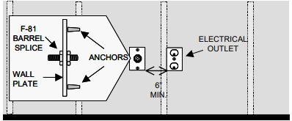

FINISHING THE INSTALLATION PROCESS

Verifying Work
Tasks listed in no particular order:
• Take time to explain to the customer how to operate newly installed equipment.
• Present the cable guide, movie guide, channel card, set top box operation booklet, Privacy Act Notification, and any other system-related material.
• Per Company policy, collect any money due and give the customer a receipt.
• Have the customer sign for the work completed.
• If you have business cards, leave one next to the set top box.
• Check all cables, connectors, and equipment connected to the cable inside and out with a signal leakage detector.
• Make sure all debris is cleaned up both inside and out.
• Put remaining tools away and check that all tools are back in your truck.
• Notify dispatch that you have completed the job.
• Pick up safety cones and signs, walk around your vehicle, and look before driving away.

